**Assignment 15.6**

**Problem Statement:**

Build and Deploy Hadoop word count program using Gradle.

Note: You can use any program of your choice.

**Solution:**

* **Gradle project build:**

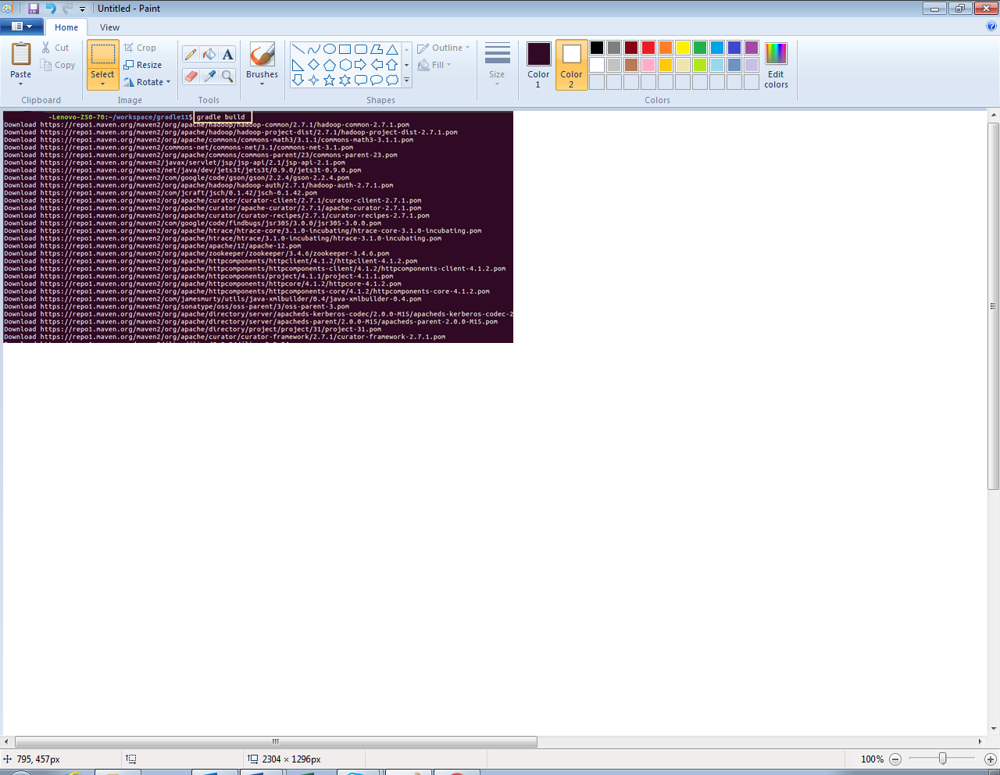

* **Gradle build file:**

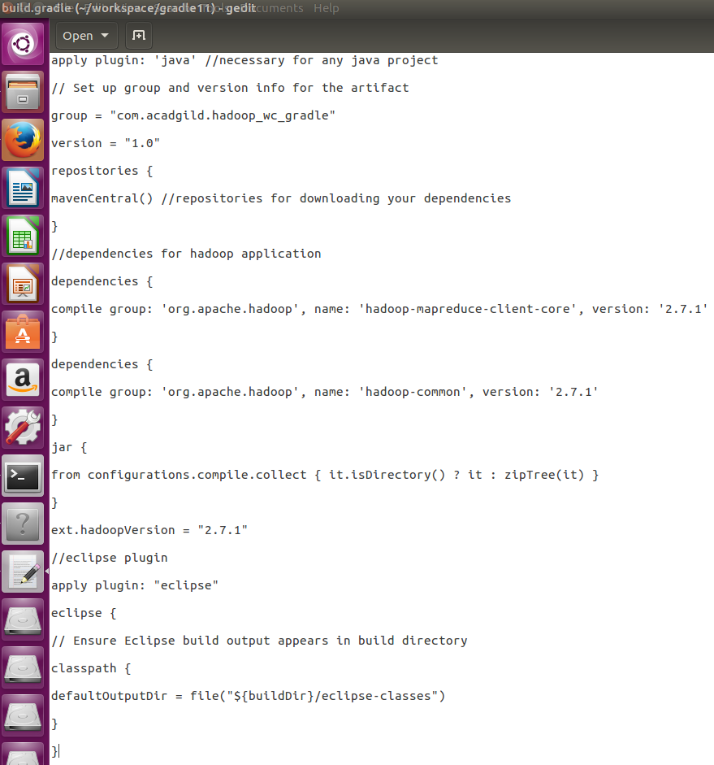

* **Word count program (java code):**

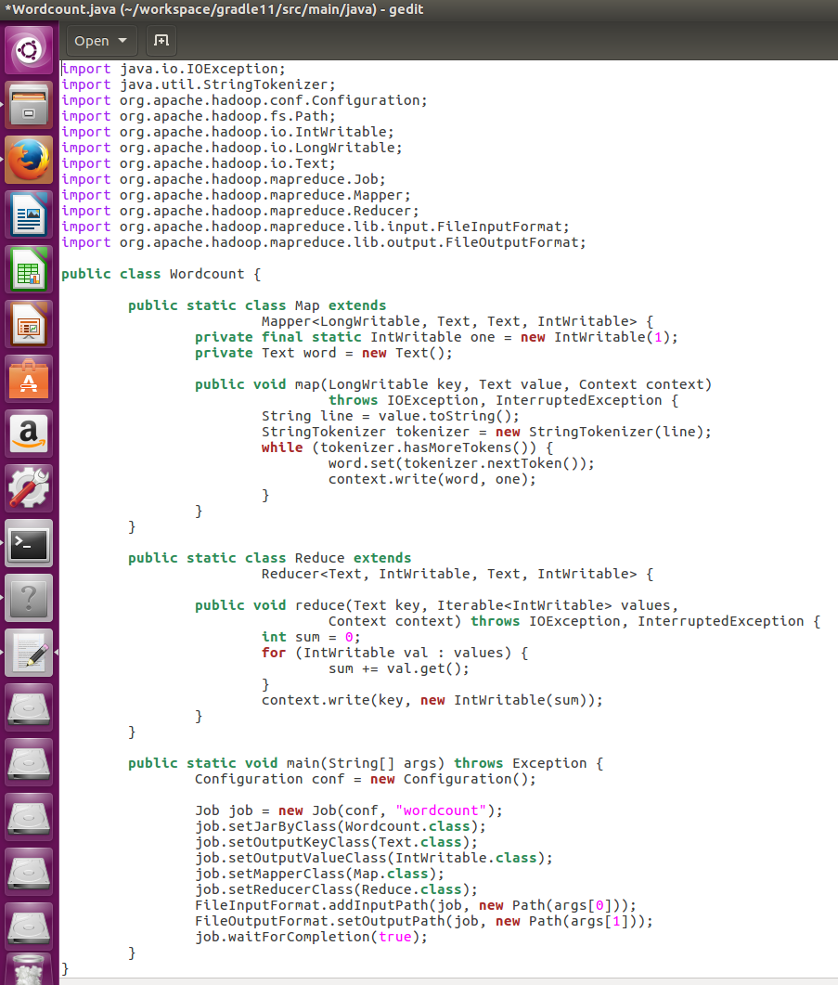

* **Running gradle project (jar file):**

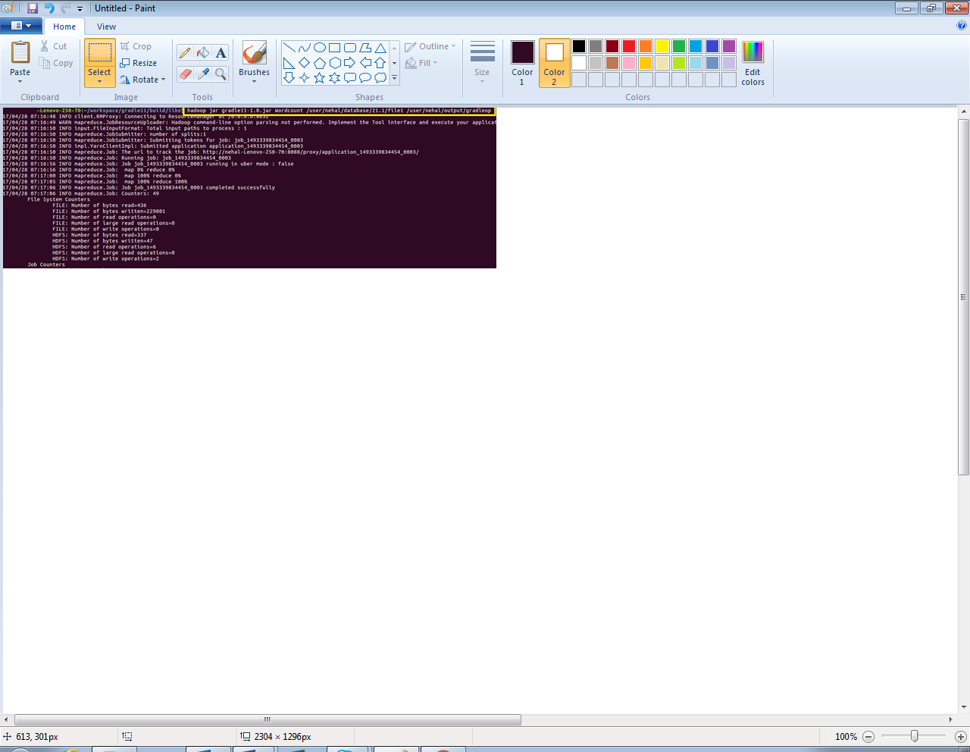

* **Output:**

